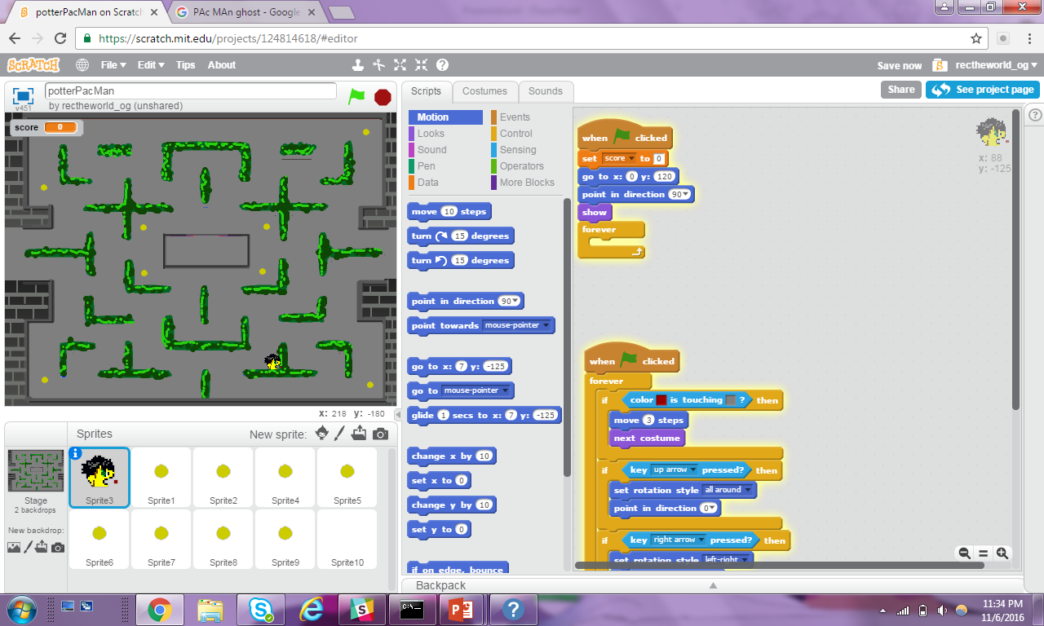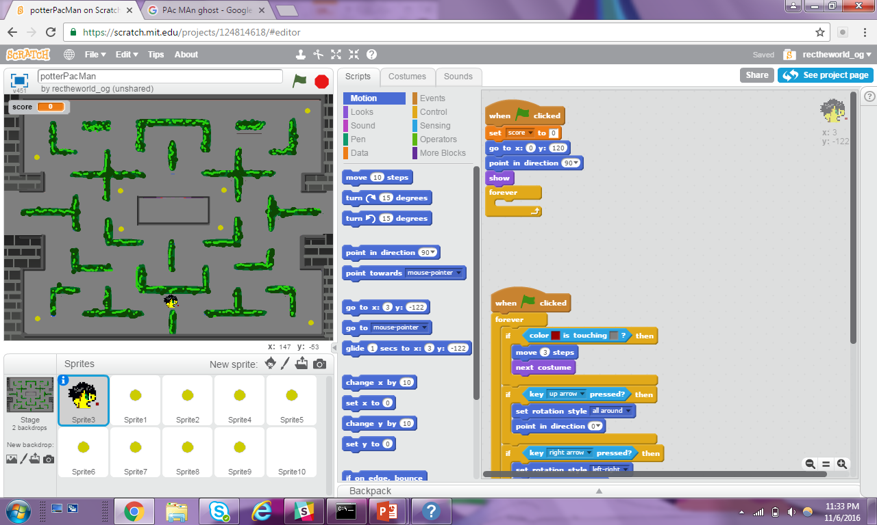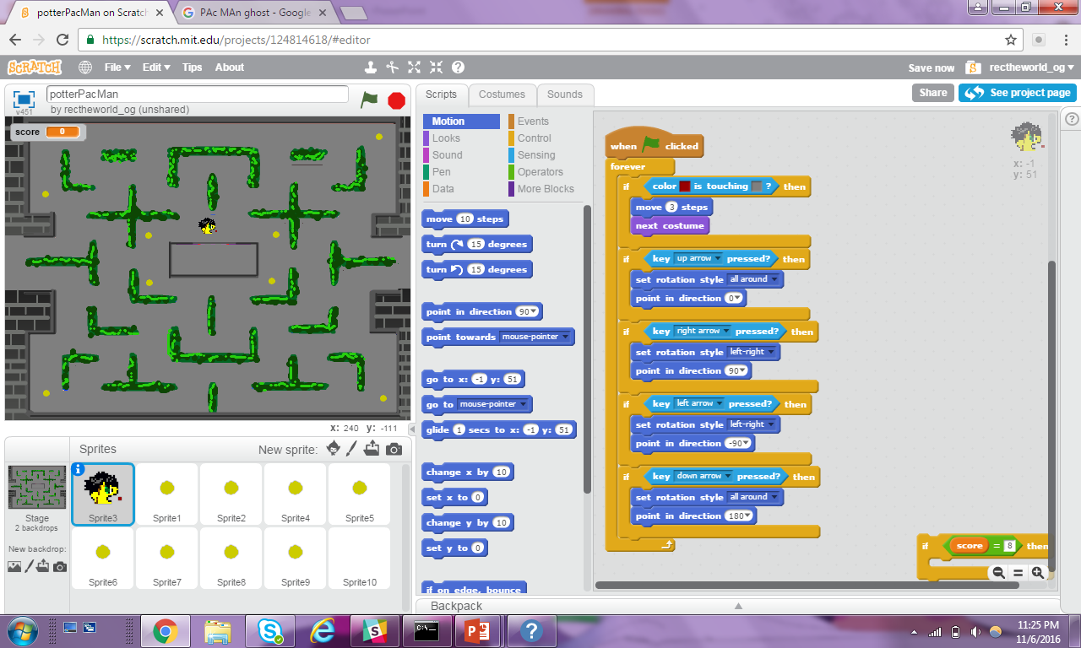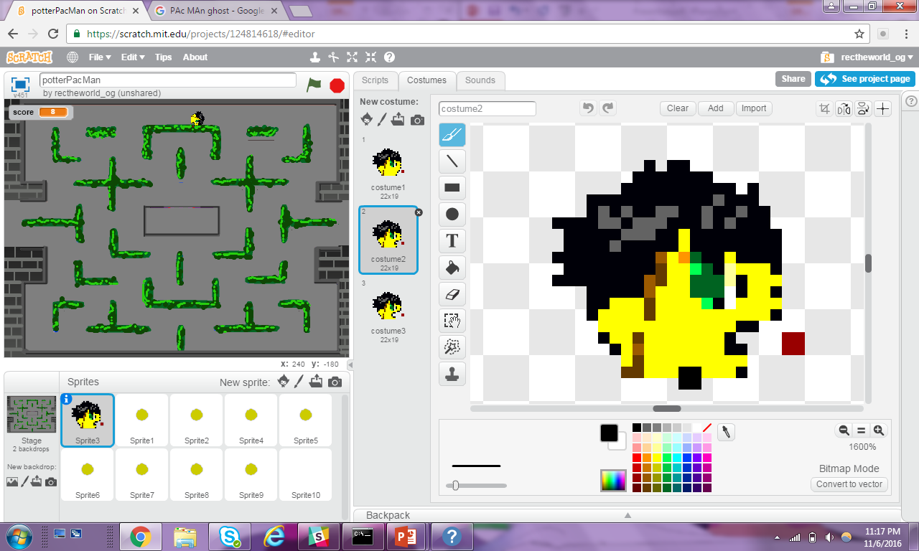Kkkkkkkkkkkkkk

(The **Dot** is touching the **Green** Wall,

and so PacMan Does not Move.)

(The **Dot** is touching the **GREY** Path,

and so PacMan Does Move.)

**IF** the **Little RED DOT** is toughing **GREY**, then PACMAN is **NOT** TOUCHING A WALL, PacMan Should move because there is nothing in front of him.

**IF** the **Little RED DOT** is toughing NOT **GREY**, then PACMAN is TOUCHING A WALL, PacMan should **NOT** **Move** because he is hitting a wall.

**PATH TOUCHING**

In the PacMan game, PacMan only moves forward if there is no wall in front of him. In other words, we need to be able to sense if PacMan is hitting a wall.

We have a **Little Red Dot** in front of PacMan.

And a Map for PacMan to Navigate.

(Notice that the PATH for PacMan is **GREY**

And the walls are **GREEN**)

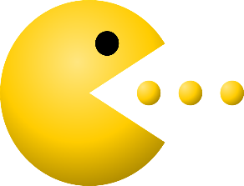

**Core Concept**: Collision Detection

Collision Detection is how we measure if the PacMan Sprite is touching something.

There are two types of Collision Detection we use in PacMan.



1

2

**CODE STORY**

When **START** 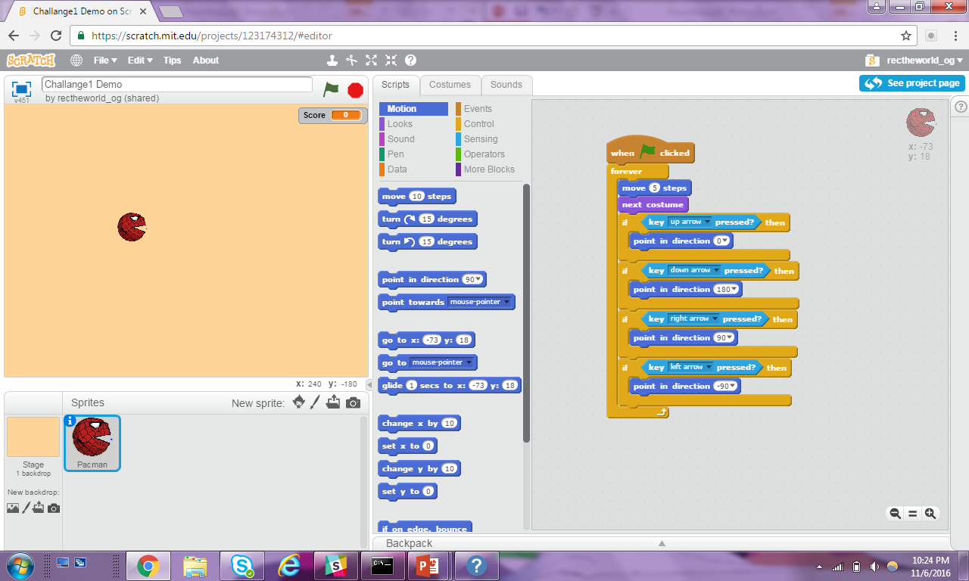 is Pressed

**WHILE** the Game is Playing

**IF** **Little Red Dot** is Touching the Path (**IF** **RED** is Touching **Gray**)

**MOVE** PacMan

**ANIMATE** PacMan

**IF** the **UP ARROW** is pressed

Rotate ‘ALL AROUND’

Point PacMan UP

**IF** the **RIGHT ARROW** is pressed

Rotate ‘LEFT-RIGHT’

Point PacMan RIGHT

**IF** the **LEFT ARROW** is pressed

Rotate ‘LEFT-RIGHT’

Point PacMan LEFT

**IF** the **DOWN ARROW** is pressed

Rotate ‘ALL AROUND’

Point PacMan DOWN



**SPRITE TOUCHING**

PacMan is able to eat pellets and be attacked by ghosts. We can sense if PacMan is eating a pellet or being attacked by using the **TOUCHING** condition.

We should add the **TOUCHING** command to the Sprite that is AFFECTED by the collision.

**Example I:**

**IF** PacMan is **TOUCHING** a Pellet **THEN** the Pellet is eaten (disappears).

In this situation the Pellet is affected because it disappears.

So the **TOUCHING** condition should do in the **Pellet’s Script Window**.

**STORY**

**CODE**

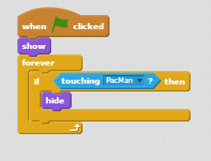

When **START** is Pressed

**SHOW** this Pellet

**WHILE** the Game is Playing

**IF** this Pellet is **TOUCHING** PacMan

**HIDE** this Pellet

**Example II:**

**IF** a Ghost is **TOUCHING** PacMan **THEN** the PacMan is eaten (disappears).

In this situation the PacMan is affected because he disappears.

So the **TOUCHING** condition should do in the **PacMan’s Script Window.**

**STORY**

**CODE**



When **START** is Pressed

**SHOW** PacMan

**MOVE** PacMan to a Starting Position

**WHILE** the Game is Playing

**IF** **Little Red Dot** is Touching the Path (**IF** **RED** is Touching **Gray**)

**MOVE** PacMan

**ANIMATE** PacMan

**IF** the **UP ARROW** is pressed

Rotate ‘ALL AROUND’

Point PacMan UP

**IF** the **RIGHT ARROW** is pressed

Rotate ‘LEFT-RIGHT’

Point PacMan RIGHT

**IF** the **LEFT ARROW** is pressed

Rotate ‘LEFT-RIGHT’

Point PacMan LEFT

**IF** the **DOWN ARROW** is pressed

Rotate ‘ALL AROUND’

Point PacMan DOWN

**IF** PacMan is **TOUCHING** a Ghost

**HIDE** PacMan

